Project Design Phase-II

Data Flow Diagram & User Stories
Date | 7th February 2026
Team ID | LTVIP2026TMIDS66183
Project Name | Civil Engineering Insight Studio
Maximum Marks | 4 Marks
Data Flow Diagrams:
A Data Flow Diagram (DFD) is a traditional visual representation of the information flows within a system. A neat and clear DFD can depict the right amount of the system requirement graphically. It shows how data enters and leaves the system, what changes the information, and where data is stored.

Flow Diagram:

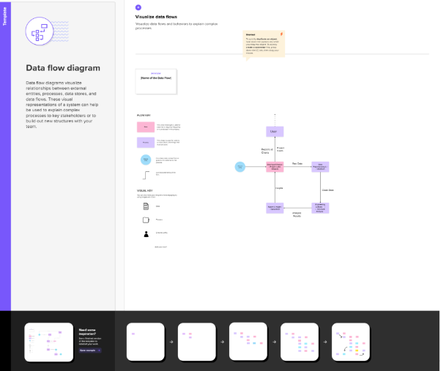
3.2.2 User Stories
Use the below template to list all the user stories for the product
User Type | Functional Requirement (Epic) | User  Story  Number | User Story / Task | Acceptance criteria | Priority | Release
Civil Engineer | Structural Performance AnalysisEstimation | USN-1 | As a Civil Engineer, I want to analyze structural loads and safety factors so that I can ensure safe and reliable designs. | System accurately calculates load distribution and safety factors. Results are clearly displayed and validated against standard engineering principles. | High | Sprint 1
SiteEngineer | Project Progress & Performance Monitoring | USN-2 | As a Site Engineer, I want to view project progress and performance insights to monitor construction activities effectively. | System displays updated project metrics such as progress status and performance indicators. | High | Sprint 1
Structural Analyst | Engineering Data Insights | USN-3 | As a Structural Analyst, I want detailed analytical reports showing stress, performance trends, and design comparisons. | Reports present clear insights across different project phases and design options. | Medium | Sprint 2
System Developer | Analytical Model Integration | USN-4 | As a System Developer, I want to integrate engineering analysis models into the platform for accurate and consistent insight generation. | Models provide reliable outputs and are well-documented for easy maintenance and expansion. | High | Sprint 2
Urban Planner | Customizable Infrastructure Insights | USN-5 | As an Urban Planner, I want customizable analytical insights to support different infrastructure development needs. | System allows parameter customization and adapts insights based on selected project conditions. | High | Sprint 3
Educational Institutions | Training Learning | USN-6 | As an academic user, I want the platform to support learning through engineering simulations and case-based analysis. | System supports testing with sample datasets and produces understandable analytical outputs. | medium | Sprint 4
QA Engineer | Testing & quality assurance | USN-7 | As a QA Engineer, I want to thoroughly test analytical modules and the interface to ensure accuracy and usability. | All modules function correctly with validated outputs and minimal errors after testing. | medium | Sprint 5

